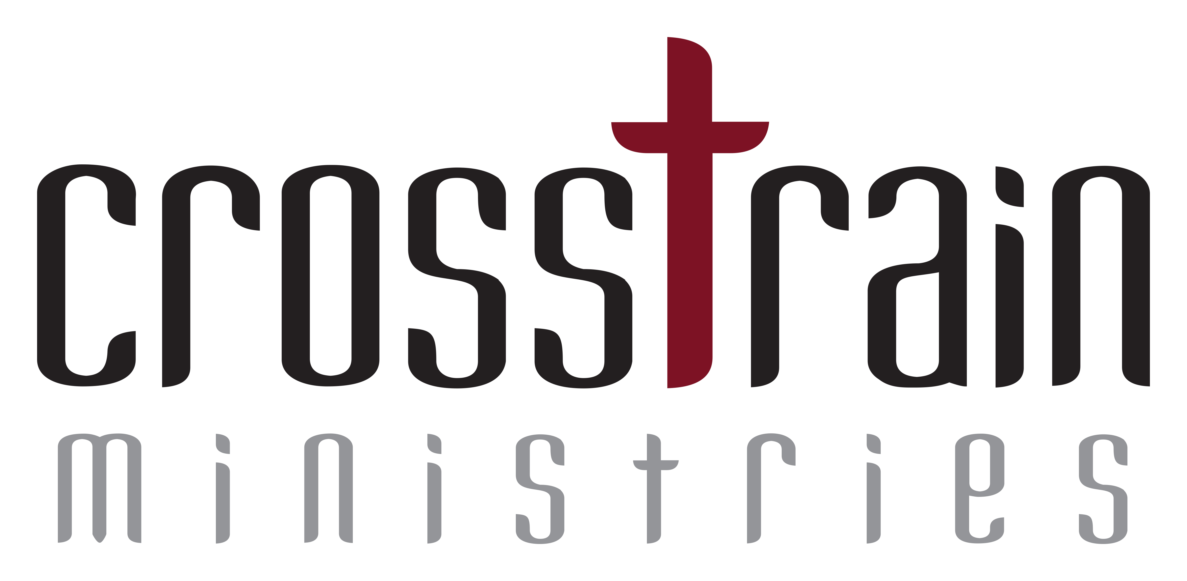
Resiliency Action Plan

1. Spiritual

What are your long-term goals?

Based on your long-term goals what short-term goals or routines would you like to set?

What do you see as possible challenges to your goals?

Other than your peer coach and Life Coach, who else could you share this with that would provide additional support?

2. Emotional

What are your long-term goals?

Based on your long-term goals what short-term goals or routines would you like to set?

What do you see as possible challenges to your goals?

Other than your peer coach and Life Coach, who else could you share this with that would provide additional support?

3. Physical

What are your long -term goals?

Based on your long-term goals what short-term goals or routines would you like to set?

What do you see as possible challenges to your goals?

Other than your peer coach and Life Coach, who else could you share this with that could provide additional support?

4. Schedule / Time Management

What are your long-term goals?

Based on your long-term goals what short-term goals or routines would you like to set?

What do you see as possible challenges to your goals?

Other than your peer coach and Life Coach, who else could you share this with that would provide additional support?

On this page write out your personal action plans for all four boxes of the quadrant:

Spiritual Action Plan

Emotional Action Plan

Physical Action Plan

Rational/Intellectual Action Plan

